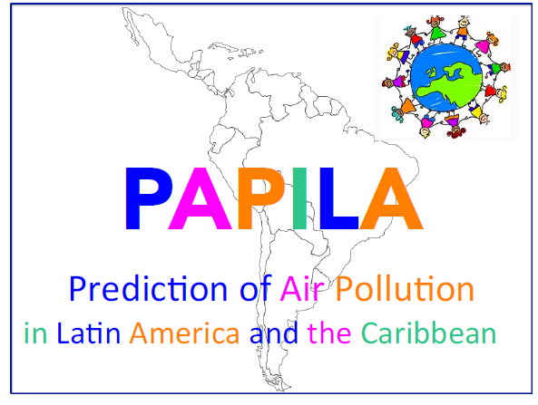

**Summer School**

**on Air Pollution Forecast Modeling in Santiago, Chile**

**28 October 2019 – 3 November 2019**

We are pleased to announce that a summer school will be organized at the University of Chile in Santiago under the sponsorship of the PAPILA Project. The school is organized in conjunction with the GEIA conference that will take place in Santiago on 6-8 November 2019.

PAPILA (Prediction of Air Pollution in Latin America) is a project supported by the European Commission under the Marie Curie Program. It involves the participation of several research groups in European countries (Germany, France, Finland, Norway, Sweden, the Netherlands) and Latin American countries (Chile, Argentina, Brazil, Bolivia, Colombia, Venezuela, Mexico, Puerto Rico).

The focus of the School will be on the development and use of air quality forecast models and will include the following elements:

* Development of emission inventories at different spatial and temporal resolutions
* Description of global and regional chemical transport models
* Initialization of model predictions including data assimilation of space and in situ observations
* Evaluation of model forecasts and comparison of model results with observational data
* Treatment of large data sets
* Assessment of impacts of air pollution
* Mitigation policies and their impact on air quality
* Dissemination of information.

A more detailed program and schedule will be communicated in the near future.

Unfortunately, the School has not yet been able to obtain funding to support participants. Therefore, we will not be able to provide funding for travel and lodging, but we will offer affordable opportunities regarding lodging in Santiago. We hope that your home institution will be able to provide the resources needed to attend the school.

The school is open for about 30 participants. Priority will be given to

* Early career scientists including post-docs involved in the PAPILA project
* Early career scientists including post-docs involved in the GEIA project
* Representatives of stakeholders and users of air quality forecasts.

To apply to the PAPILA School, please send an email to [ina.doege@mpimet.mpg.de](mailto:ina.doege@mpimet.mpg.de) and provide the following information before the deadline of **15 July 2019**:

1. Full name
2. Affiliation
3. Current position
4. Address of your host institution
5. Telephone
6. Email address
7. Education:
8. Work experience (5 lines)
9. Motivation to attend the school (5 to 10 lines)
10. Topic of particular interest in the school foci.
11. Name of supervisor or advisor.

We hope very much that you are interested by the opportunity to attend lectures, participate in group discussions and meet professional colleagues at this occasion.

Guy Brasseur

Coordinator of PAPILA

Max Planck Institute for Meteorology

Hamburg, Germany

[guy.brasseur@mpimet.mpg.de](mailto:guy.brasseur@mpimet.mpg.de)

